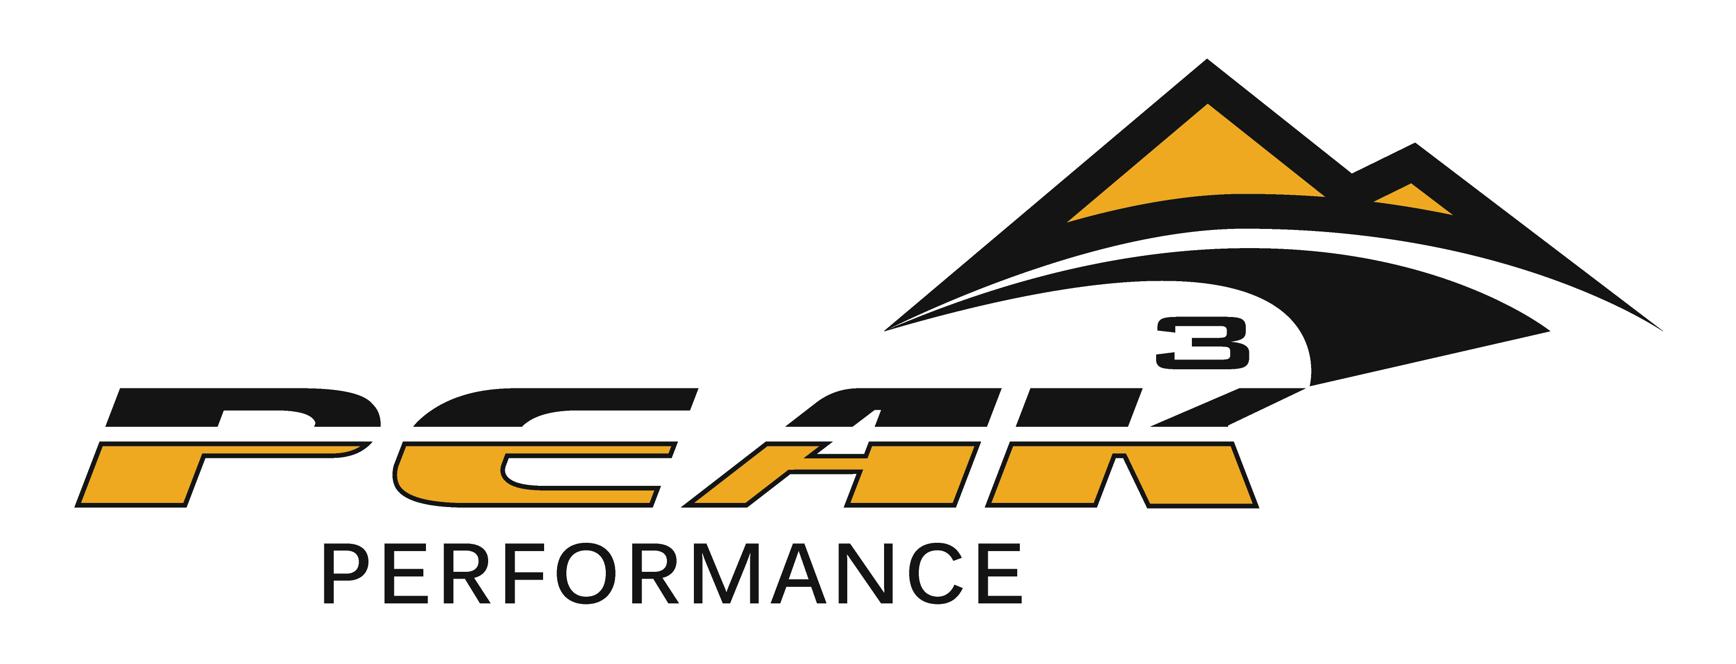

Peak Performance
CSCS/Athletic Trainer/Massage Therapy
Sports Medicine Internship

Bobby Reisz, MSE, ATC, CSCS, LMT
Owner
515-577-7901
peakperformancesportstraining.com

Internship and Job Description

Through education, motivation, and leadership, the intern will work together with our sports medicine team and assist member-clients in establishing and reaching their fitness/wellness goals. The intern may also participate in ATC coverage to various athletic events. To help oversee the overall health and well being of all high school, intercollegiate athletes through athletic training duties. The intern should contribute to the overall success of the Fitness Center by embodying the mission, vision and values of Peak Performance.

Qualifications

- Pursuing a degree in Exercise Science, Wellness Health Promotion, or related health field
- Experience and interest in the fitness/wellness field
- Exceptional written and verbal communication skills, including ability to deliver presentations
- Must possess good organizational skills and be efficient in multitasking Ability to work independently and in a group setting
- Ability to work in a dynamic, changing, and diverse environment

Requirements

- Current CPR certification, First Aid, and possibly BBP/MRTK training
- 10 week minimum commitment to Peak Performance for full internship experience
- Full or part-time student in good academic standing
- Recent medical examination as required by the academic department
- Hepatitis B Vaccination (or declination) Records
- Adherence to rules and guidelines set forth by the Peak Performance Sports Medicine staff along with Grand Slam USA and F3 Fire Policies and Procedures.

Mandatory Working Conditions

- This is an Education filled Internship position.
- Attendance is required
- Many weekend and evening hours required and may be extensive seasonally
- May be necessary to work in all extreme weather conditions.
- Ability to lift/transport athletes, coolers, other related materials.
- Do not get the normal college holiday breaks due to practices, travel and competitions.
- Flexibility with the scheduling is a must. There may be some inconsistencies with the schedules week to week.
- Team concept is a must.
- There should be no separation between employee and employer.

Essential Duties/Responsibilities

In order to maximize student learning in a field experience, certain expectations and responsibilities must be assumed by the student. These responsibilities represent a wide range of behavioral and attitudinal characteristics, as well as work site competencies that are part of the specific assignment.

- To conduct oneself in a professional manner which reflects favorably upon Peak Performance, the University, as well as the student
- Notify Peak Performance staff of any unavoidable absences or tardiness to be anticipated
- To be ethical in dealings with co-workers and clients and to maintain loyalty to Peak Performance and its programs
- To develop and maintain periodic and on-going goals and objectives which fulfill Peak Performance and internship responsibilities
- To take initiative to seek help and advice from appropriate staff when needed
- To notify Peak Performance staff of any situation that warrants special attention immediately
- To display interest, resourcefulness, and commitment in approaching problems and finding solutions
- To keep Peak Performance staff informed through scheduled reports related to the internship experience
- Assist in compiling participation data and the completion of necessary reports for patients/clients
- Perform fitness evaluations for fitness program participants, personal training clients, and possibly surrounding school athletic teams
- Summarize and interpret fitness test data and prescribe cardiovascular and strength exercise programs for healthy individuals
- Job shadow a member of the Peak Performance Sports Medicine staff and train a minimum of one client
- Develop and/or implement at least one special program with a client of the Peak Performance Staff’s choosing
- Demonstrate ability to teach a minimum of one group exercise class format through team teaching
- Prepare and deliver a minimum of one health/wellness educational program each semester to Peak Performance staff of their choosing
- Instruct special fitness programs as needed
- Implement building emergency procedures as necessary
- Assist fitness/wellness staff with general day-to-day duties of the office
- Participate in each group exercise class format a minimum of two times per week
- Attend all regularly scheduled office hours and meetings
- Other responsibilities as agreed upon by the Peak Performance Sports Medicine Staff
- Maintain and complete all house keeping duties assigned by staff Complete house keeping weekly check list

Athletic Training Focused Intern

PRINCIPLE DUTIES AND RESPONSIBILITIES % OF TIME FREQUENCY
I. Practice/game supervision/attendance 90% Daily (7x/wk)
- Injury prevention
- First Aid
- Injury assessment
- Sports injury treatments
- Orthopedic rehabilitation
- Counseling/sport psychology

II. Administration 10% Ongoing
- Assist staff ATCs with scheduling
- Assist with inventory/budgets
- Maintain documentation of injuries and athletic training student experience hours

Supervision/Compensation

- Direct report is to the Peak Performance Sports Medicine Staff
- This is an unpaid internship
- To reach the required number of hours for the experience, interns typically work 20-40 hours/week with a minimum commitment of 10 weeks
- This is a multiple semester internship opportunity

____________________________________________________________________
********************************************************************
All of the above duties and responsibilities are essential job functions subject to reasonable accommodation. All job requirements listed indicate the Minimum level of knowledge, skills and/or ability deemed necessary to perform the job proficiently. This job description is not to be construed as an exhaustive statement of duties, responsibilities or requirements. Interns may be required to perform any other job-related tasks as requested by their supervisor, subject to reasonable accommodation.

……………….
Date

……………………………………………….
Intern signature

………………………………………………..
Supervisor's signature

Application Process

Interested and qualified individuals should send an application, cover letter, resume including a minimum of three references (may be work or academic) to:

Peak Performance Peak Performance Peak Performance
ATTN: Bobby Reisz ATTN: Bobby Reisz ATTN: Bobby Reisz
4137 120th Street 14242 C Circle 302 Cary St
Urbandale, IA 50323 Omaha, NE 68144 Papillion, NE 68046

Email: PeakPerformance21@gmail.com
Phone: 515-577-7901

Emailed application materials must be in word format. Interviews will be conducted of qualified applicants prior to offering the internship position.

